**ASSIGNMENT – 1 ( Level 1 )**

**NAME : VINAY P**

Step 1 : Java installation

I have already installed the latest version of JAVA and also setup environmental variables, so I am inserting some images and running in command prompt with java –version which shows version so that I can show that I have installed my java version.

**HOW EVER JAVA JDK DOWNLOAD LINK :** [**https://www.oracle.com/in/java/technologies/downloads/#jdk20-windows**](https://www.oracle.com/in/java/technologies/downloads/#jdk20-windows)

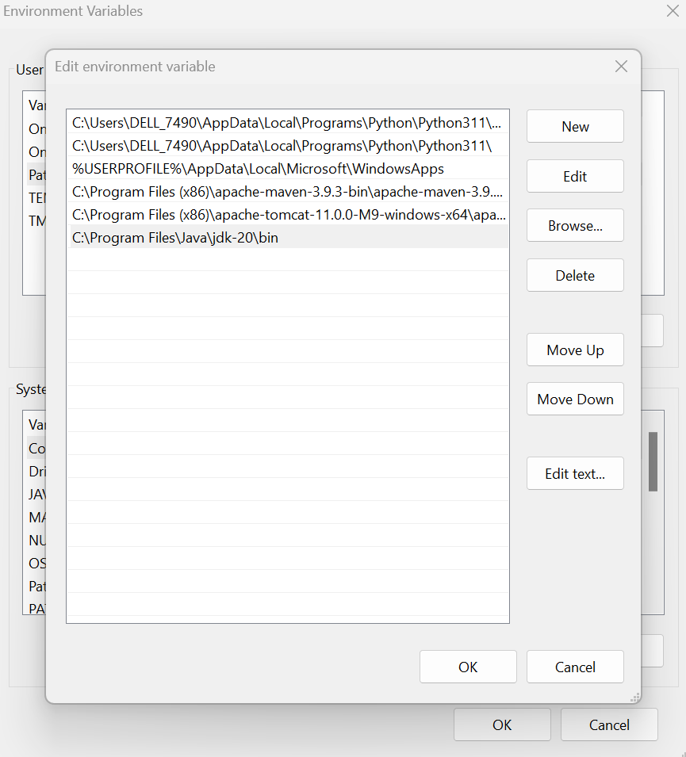

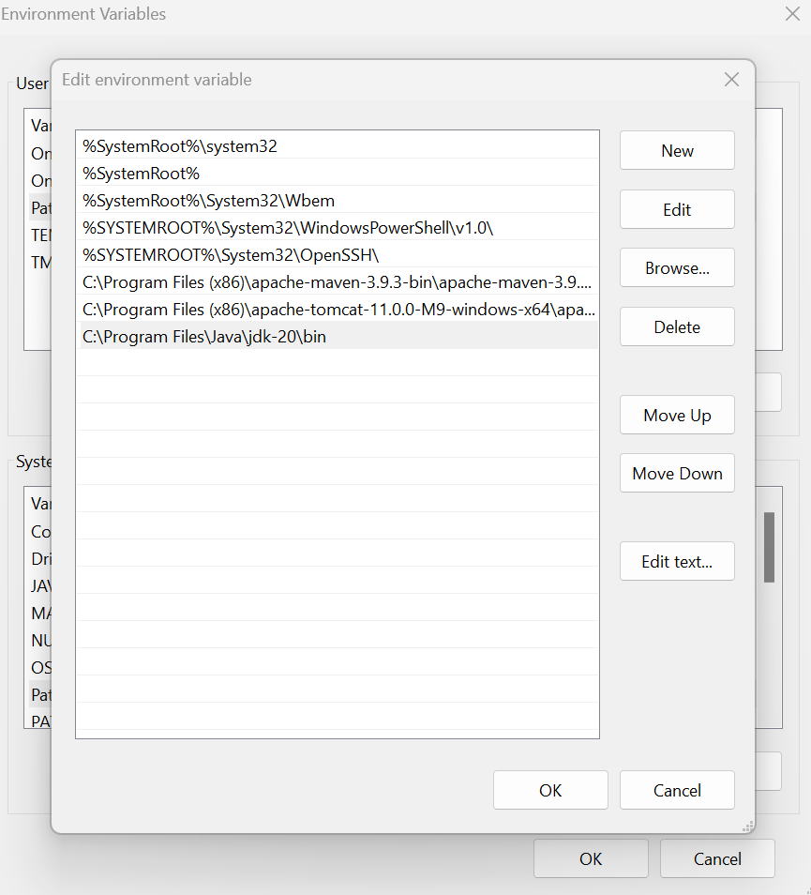

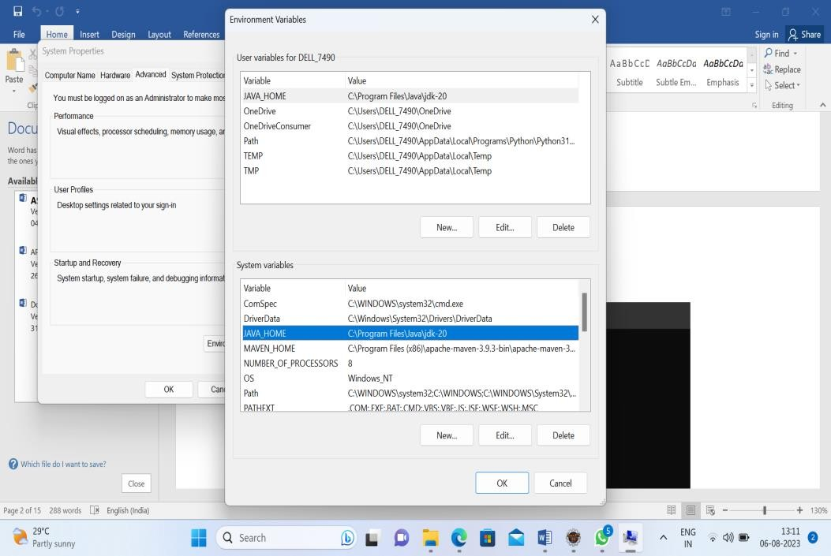

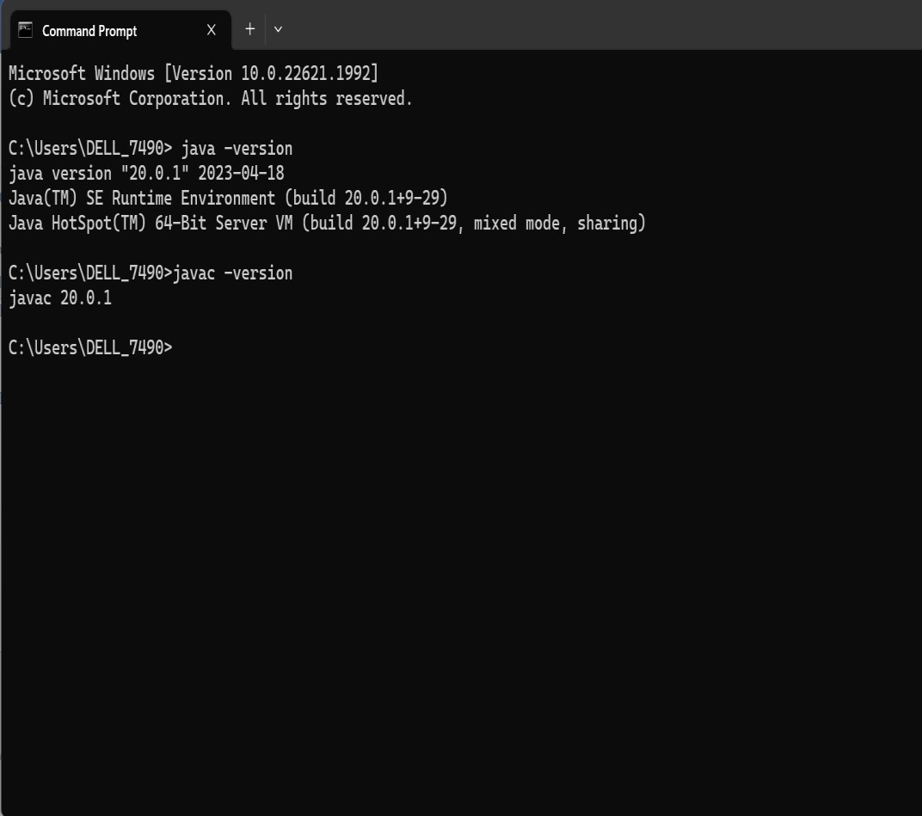

Step 2 : Installation of eclipse from eclipse foundation (official website)

**https://www.eclipse.org/downloads/download.php?file=/oomph/epp/2023-06/R/eclipse-inst-jre- win64.exe**

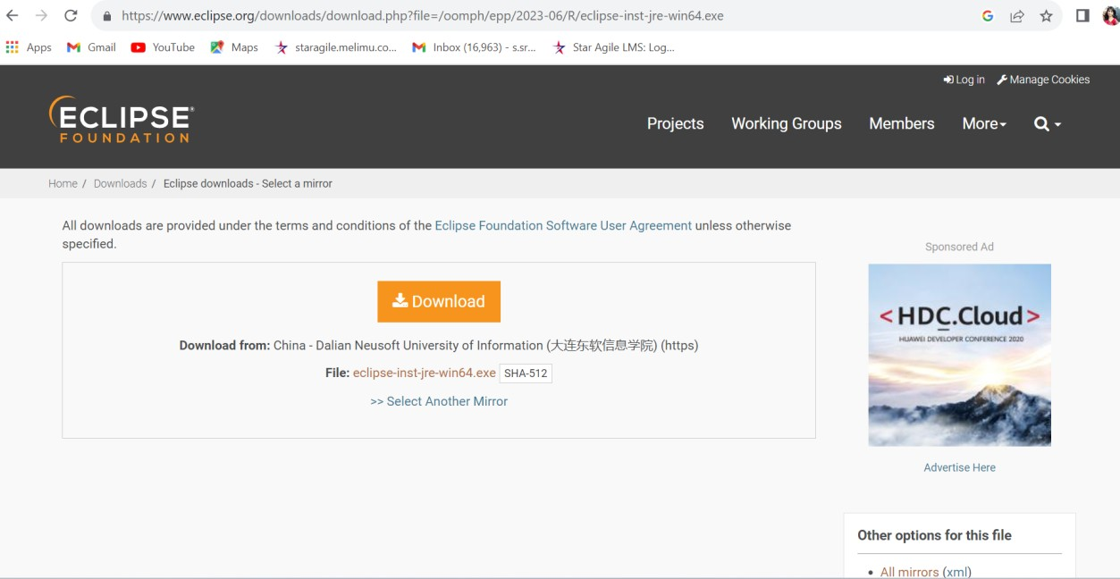

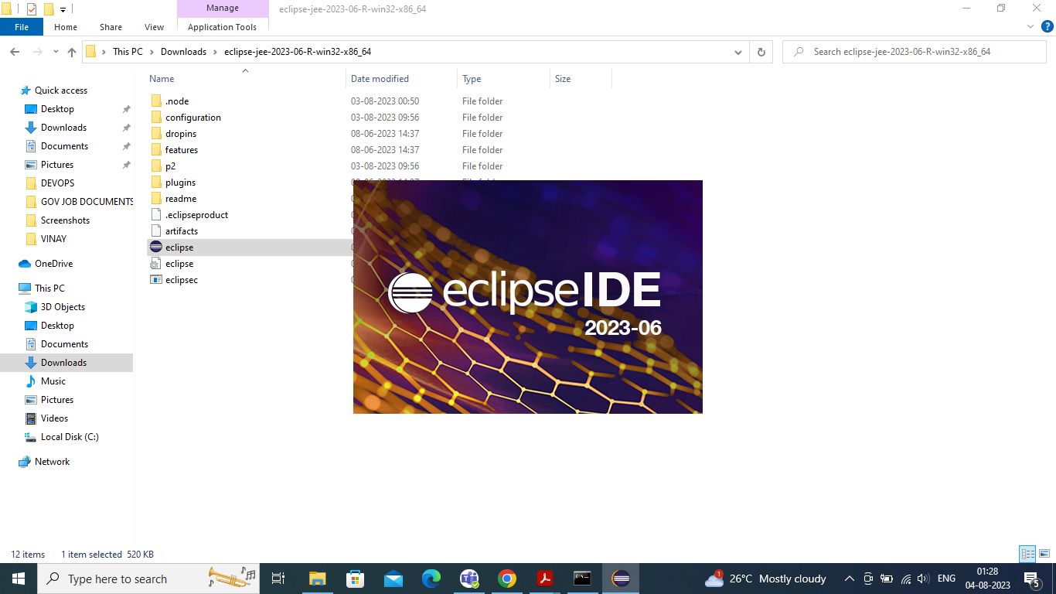

Installation completed & Ready to work on project :

Since it was mentioned that we have to download the JAVA 8 version and I can select the java environment/version to be used for our project also 8 is not available so I do select JavaSE17.

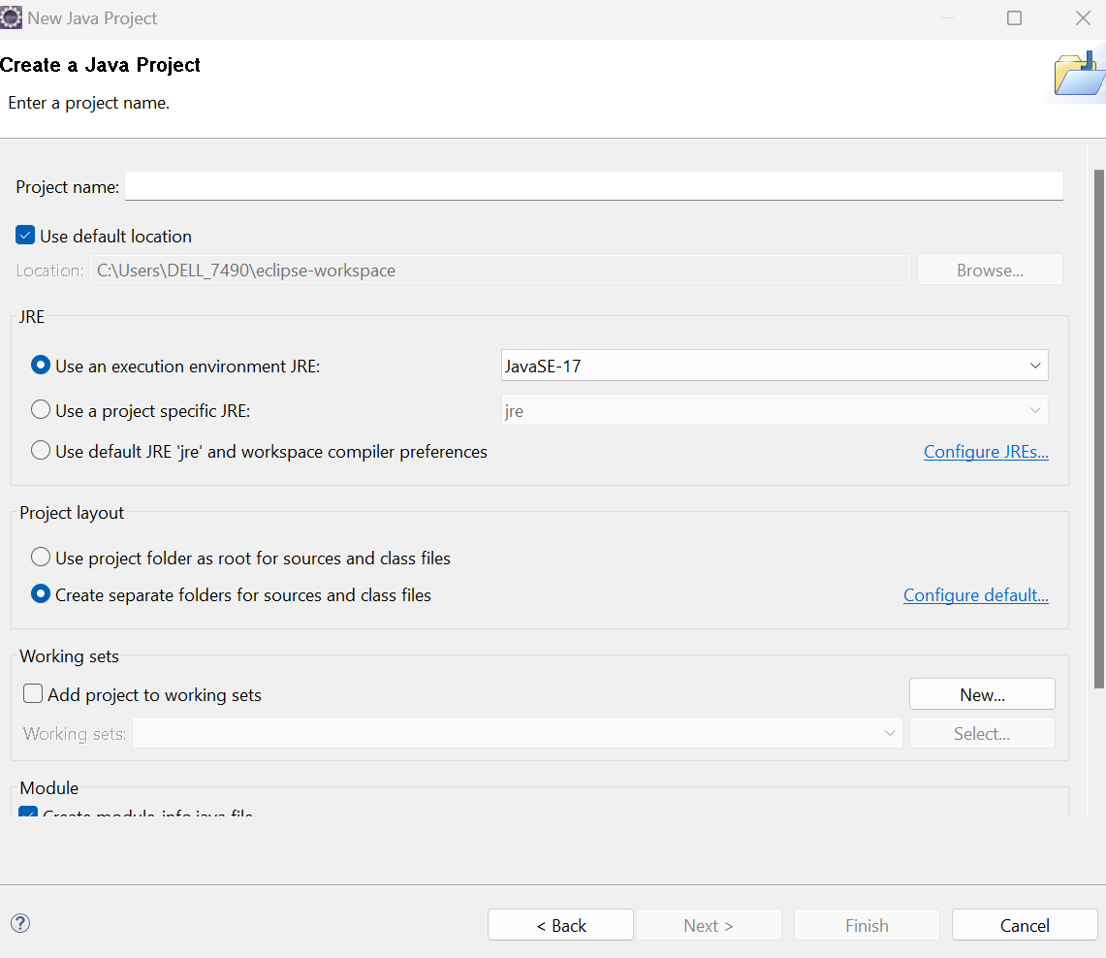

STEP 3 : Installation of Apache Tomcat runtime/ server <https://tomcat.apache.org/download-10.cgi>

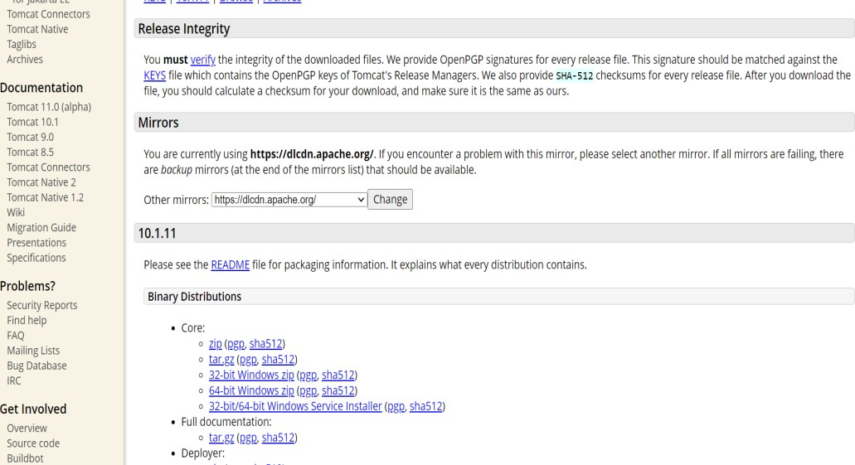

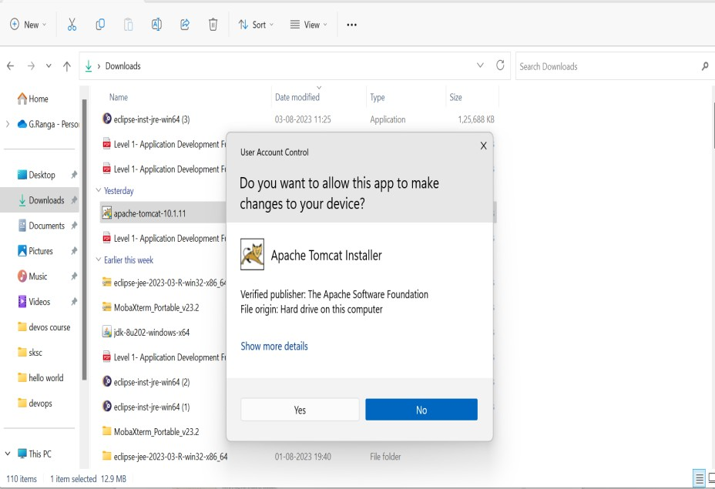

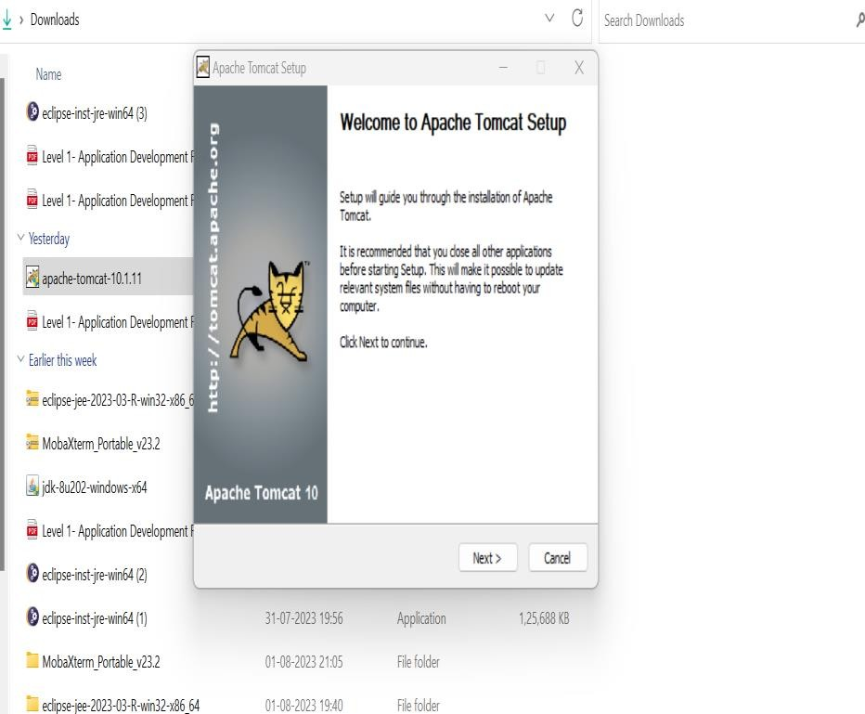

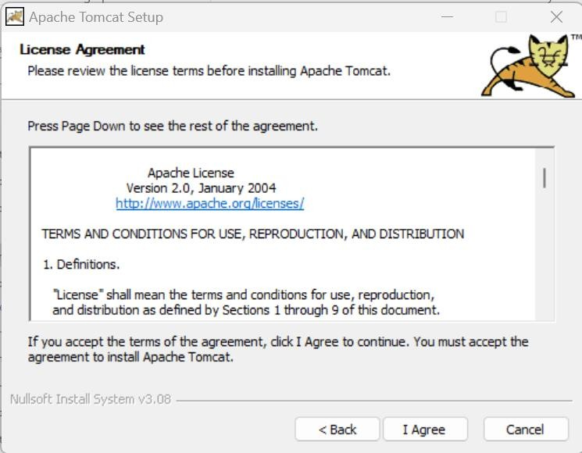

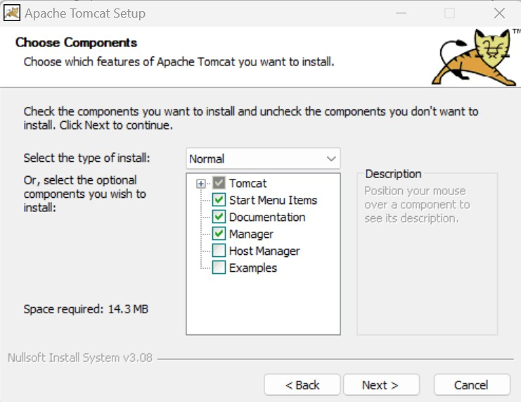

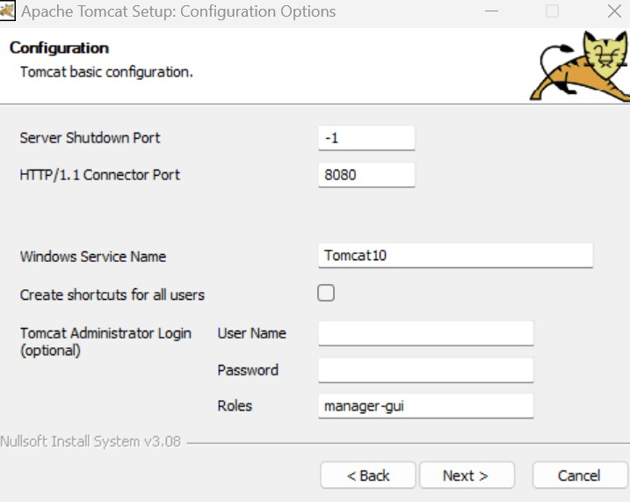

I have already installed Tomcat server.

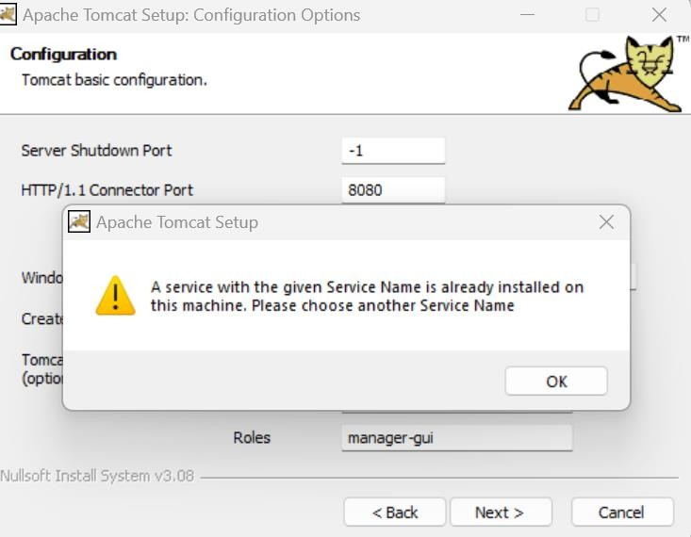To creat Dynamic web project, we need to select the preference to JAVA EE, before that we have to download it by clicking help on top install new sowftware & select java EE, then give preference to Java EE on clicking on top right preference button.

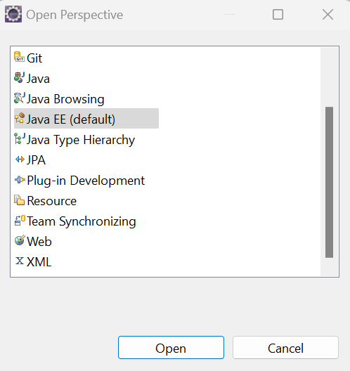

Now we can see the DYNAMIC WEB PROJECT option

**Step 4 : Create a java dynamic web project**

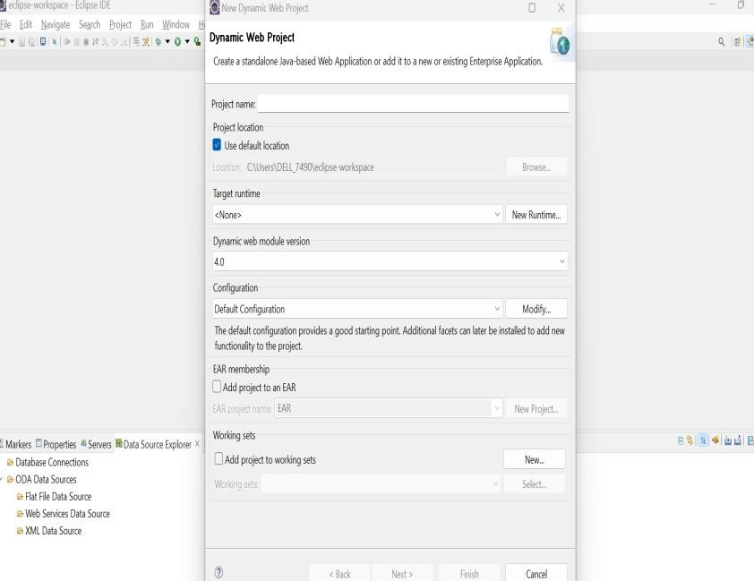

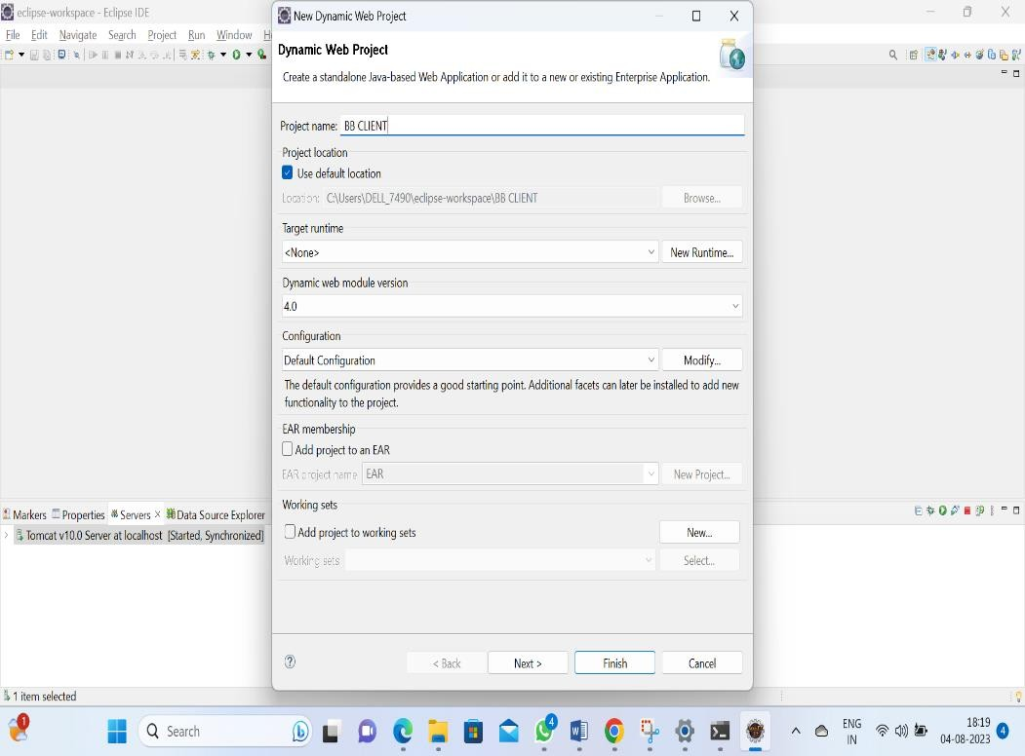

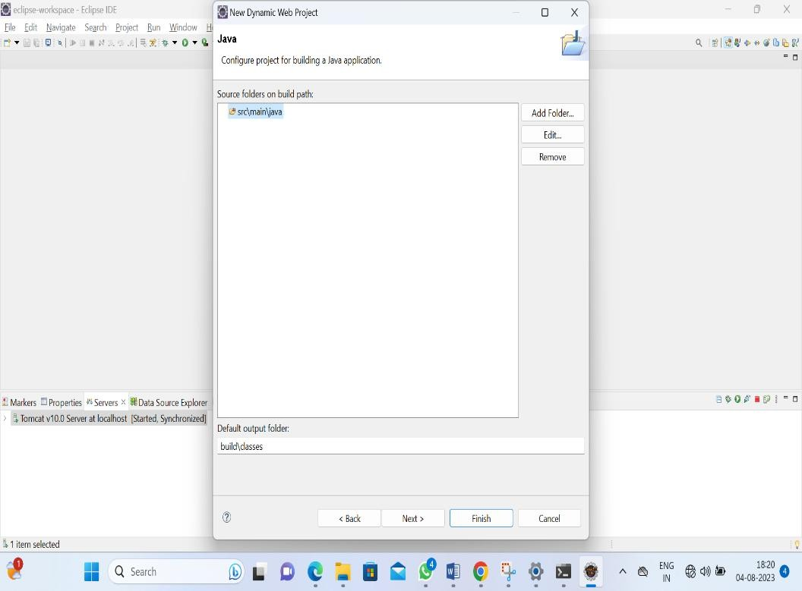

Step 5 : Configuring tomcat server in Eclipse:

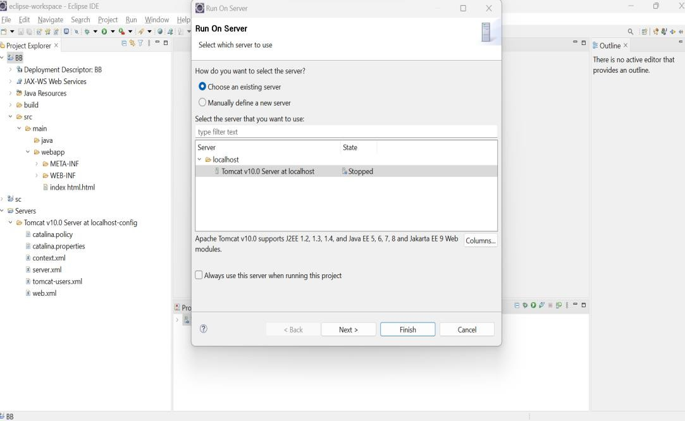

**Step 6 : Create an index.html file:**

Click on web-inf then select NEW option and then click on NEW HTML FILE select on that option later create file name index.html, now

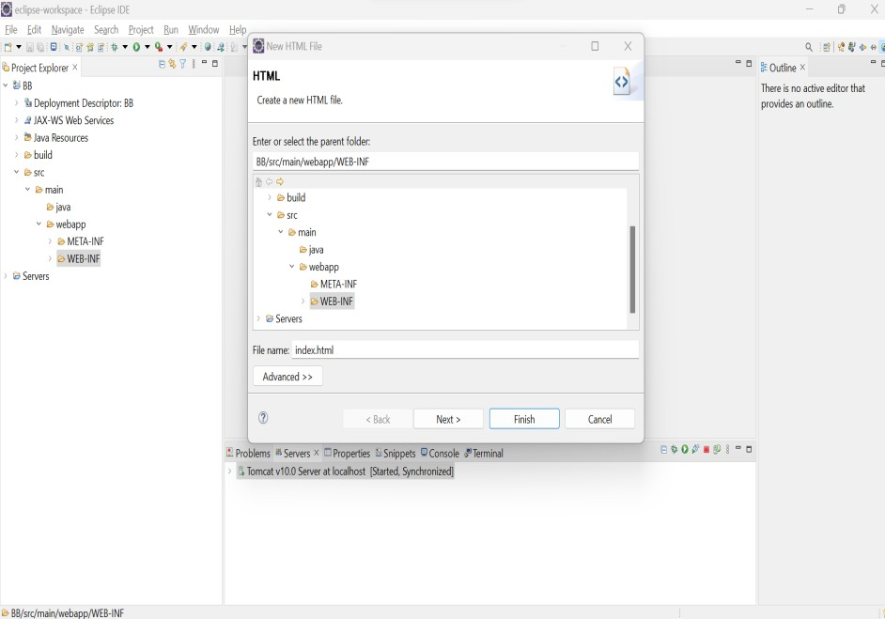

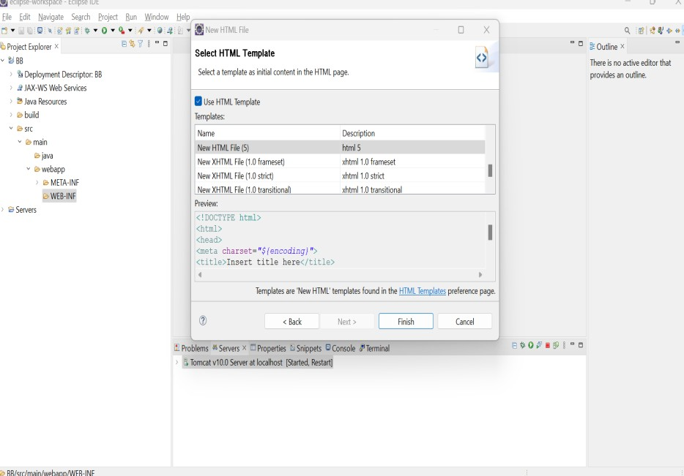

**creating INDEX .HTML FILE is completed now write some HTML code & run my server it will open in my browser & I can see my Html page.**

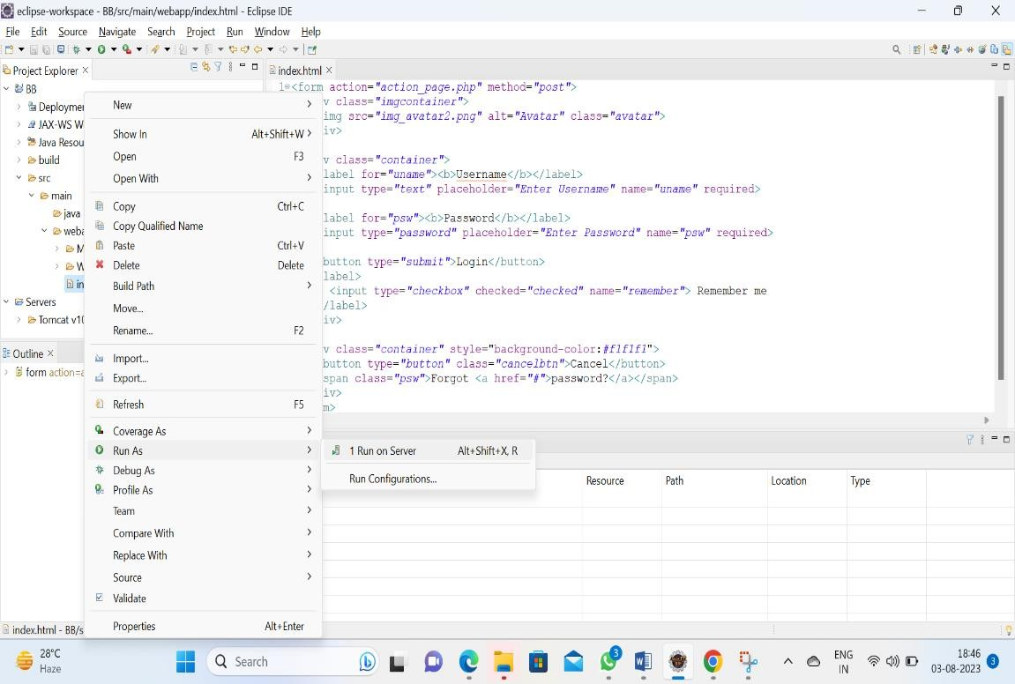

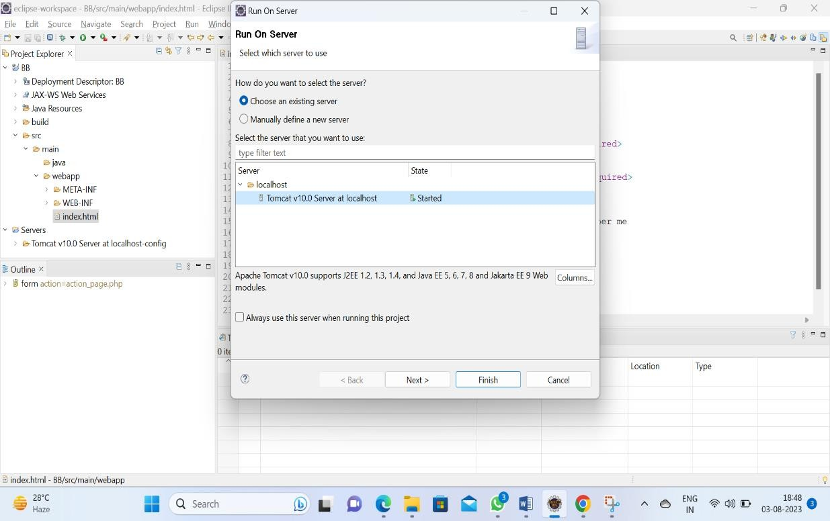

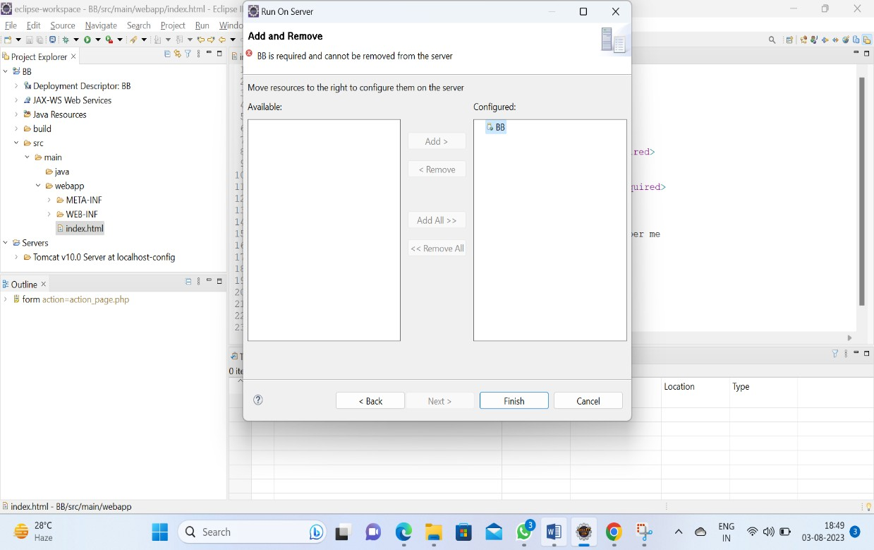

**Now in below screenshot we can see the index.html is deployed & we can see the structure of HTML.**

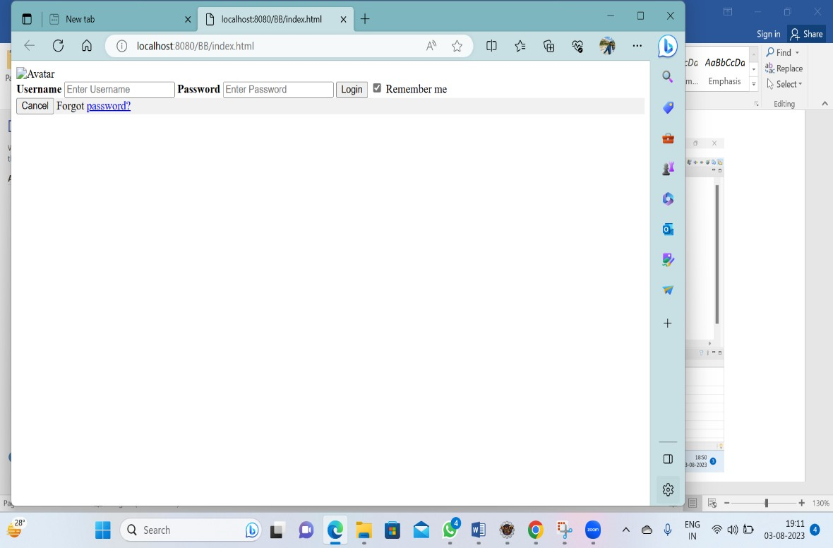

**Step 7 : Start the server.**

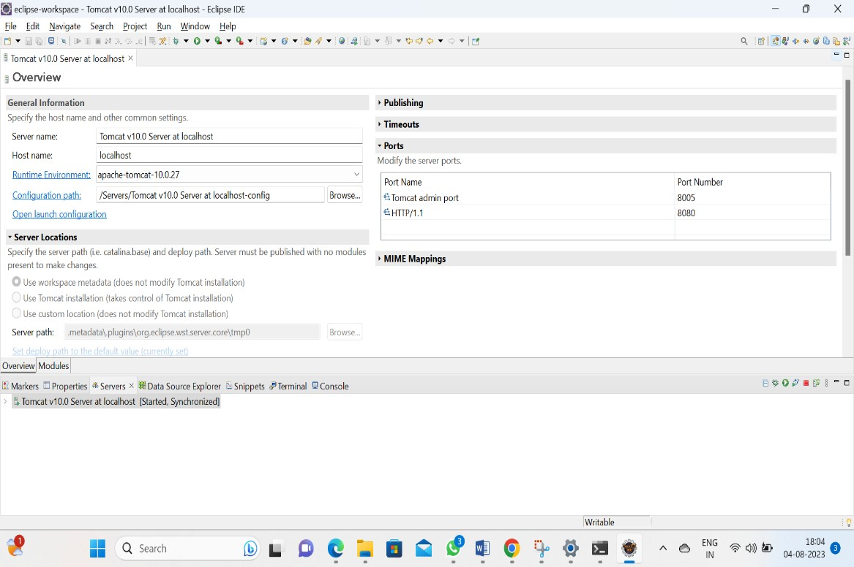

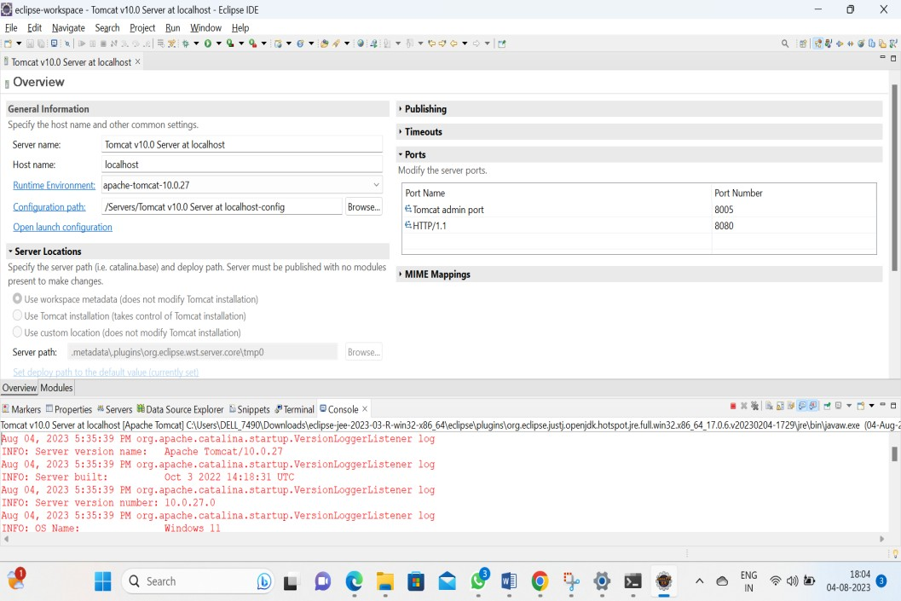

**Step 8 : Verify the application is up and running**

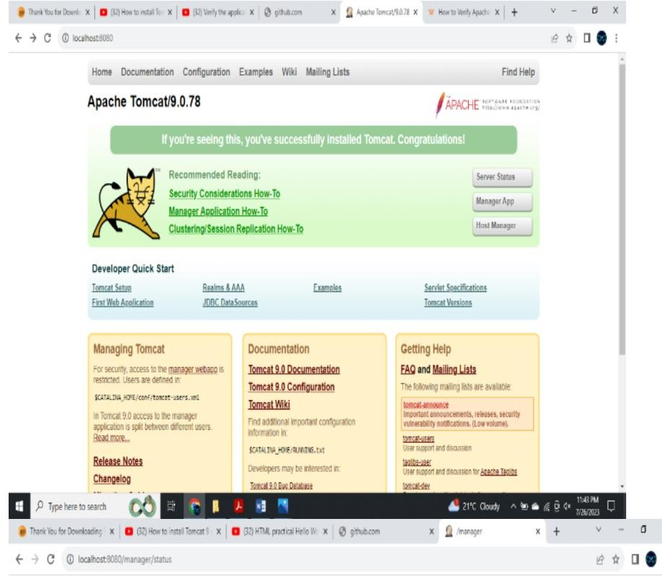

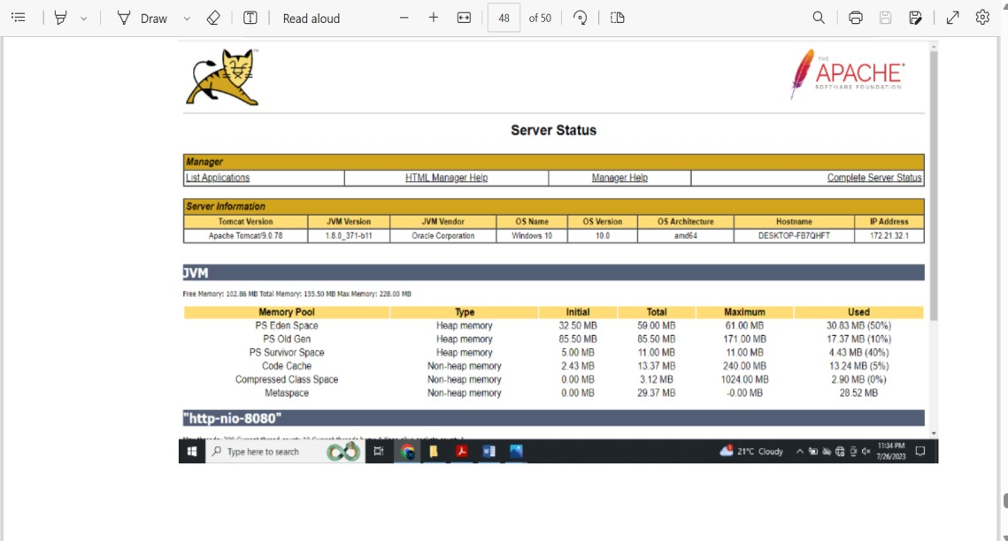

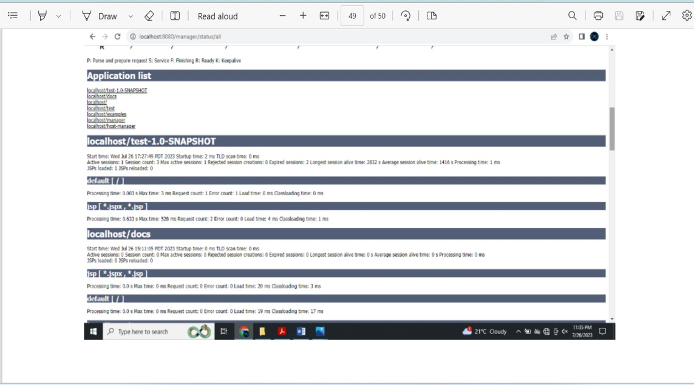

THANK YOU - STAR AGILE

THIS IS MY LEVEL – 1 ASSIGNMENT

**ASSIGNMENT – 1 ( Level 2 )**

**NAME : VINAY P**

**Step 1 : Create a Java Project**

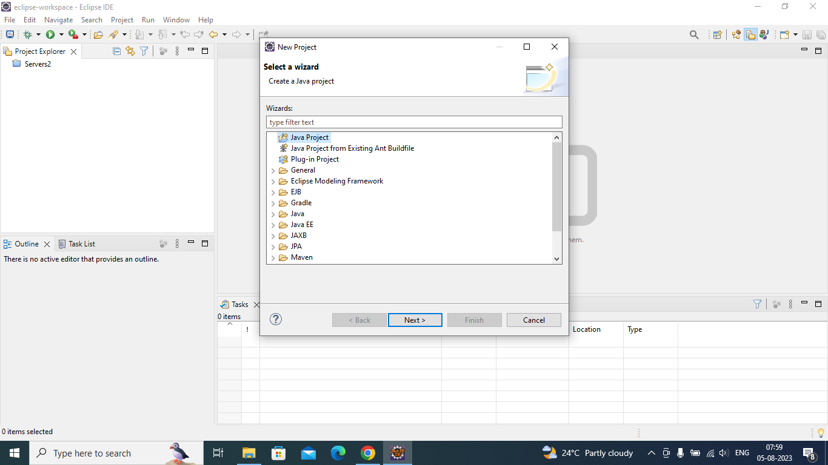

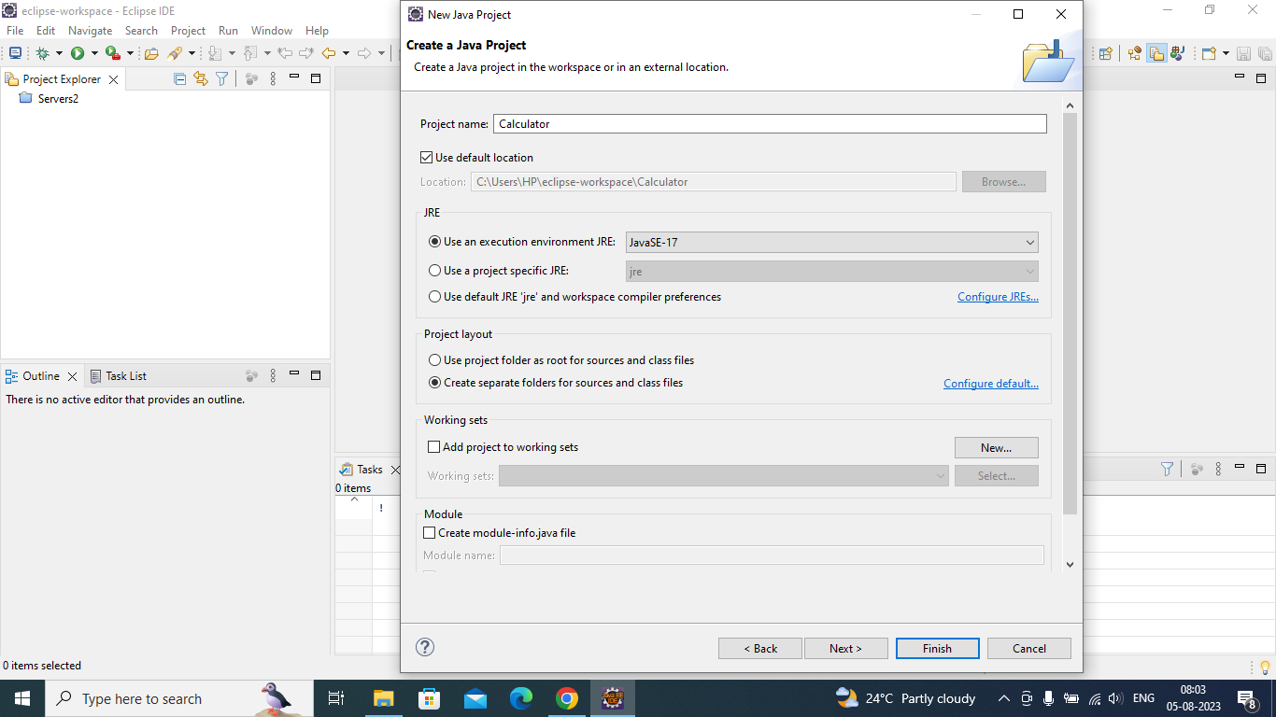

**Step 2 : Create a java package**

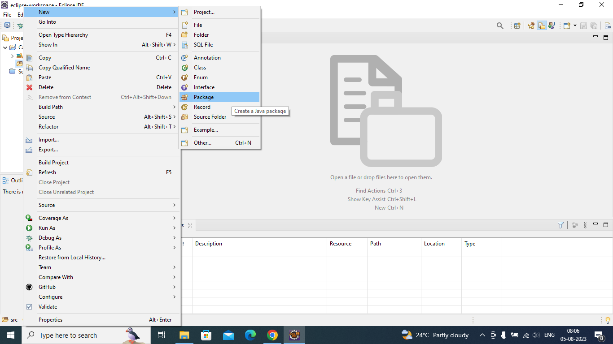

**Step 3 : Create a class Calculator.java**

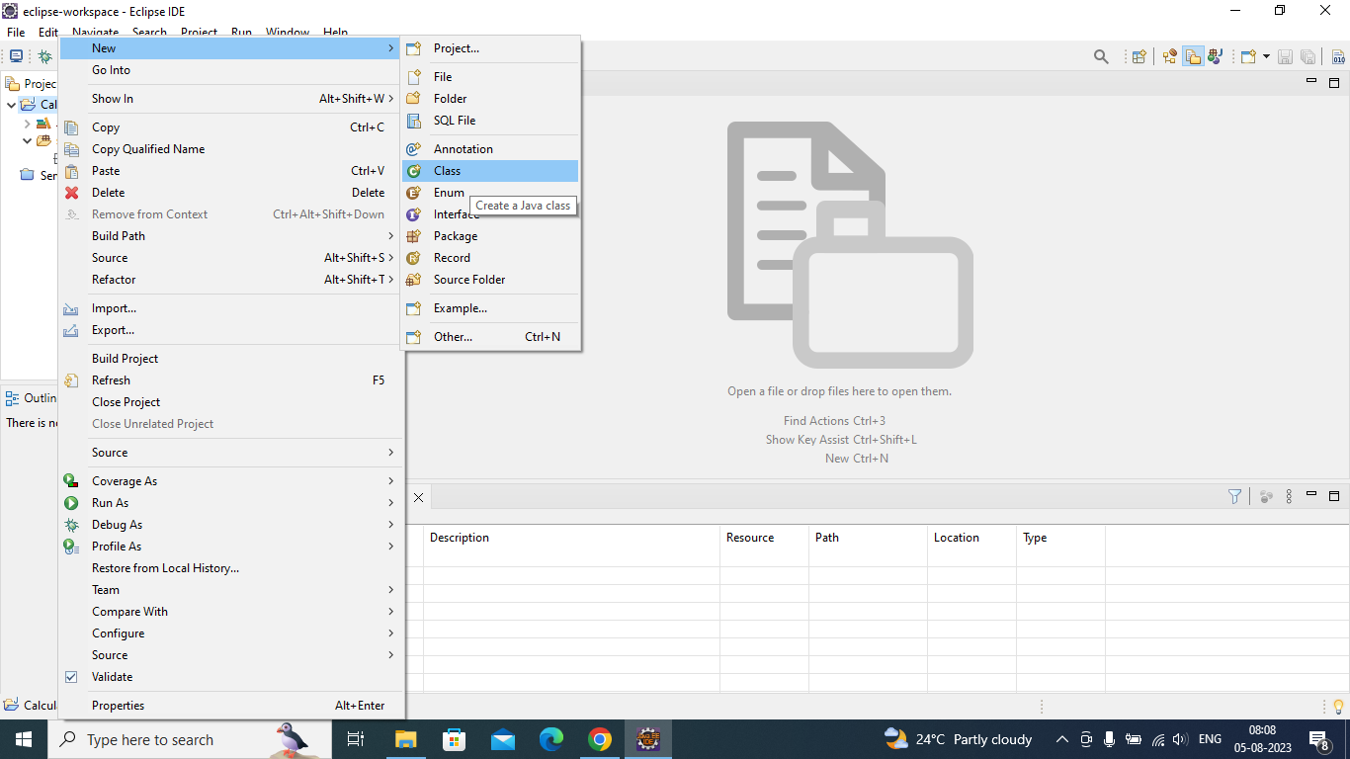

**Step 4 : Written 4 public methods for (Sum, Subtract, Multiply, Divide)**

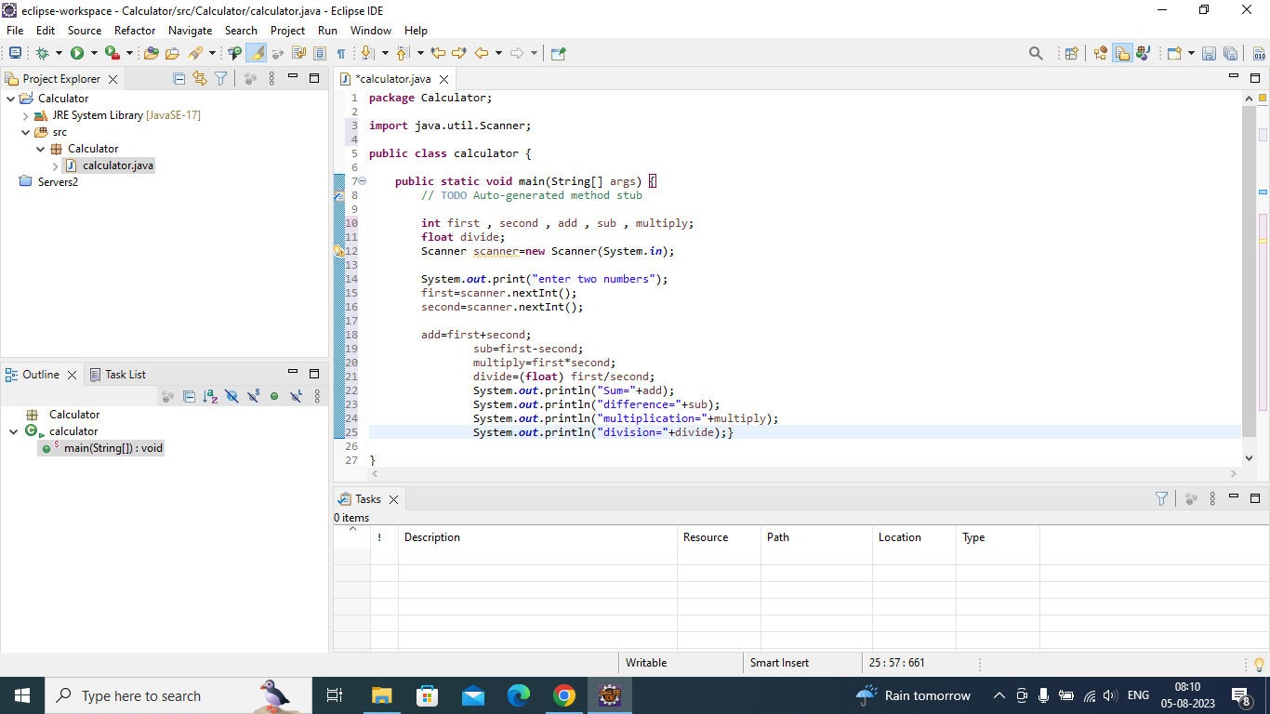

**Step 5 : Each method takes 2 integer values as input**

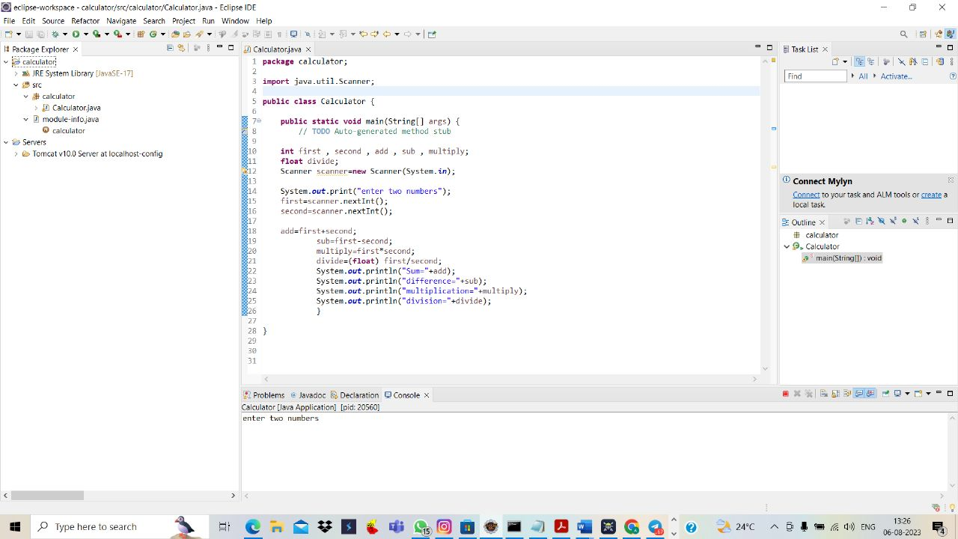

**Step 6 : Read the onput from the console**

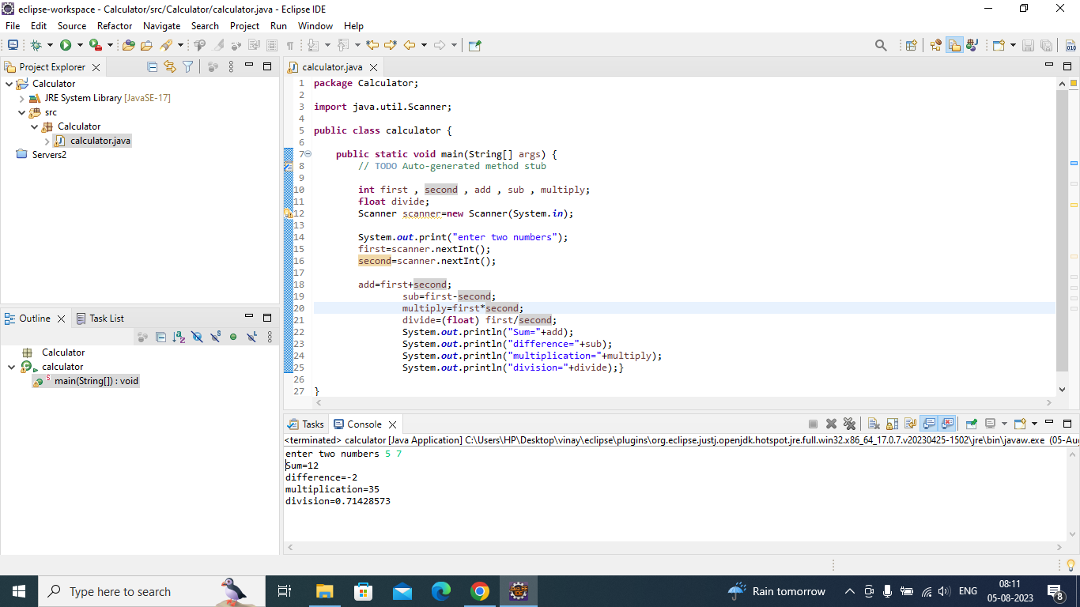

**Step 7 : Write the main method to read 2 input values from terminal**



**8. Import the Junit jar.**

**9. Write the Junit testcases for each of the 4 methods**

**10.Run the test cases to validate the method output**

* **Junit jar not explained for us, so I did not attempt above three questions**
* **Later I will submit this Junit jar, when the Junit jar portion complete.**

**THANK YOU – STAR AGILE TEAM**

**THIS IS MY LEVEL – 2 ASSIGNMENT**